VIVEKANANDA INSTITUTE OF PROFESSIONAL STUDIES-TECHNICAL CAMPUS

VIVEKANANDA SCHOOL OF INFORMATION TECHNOLOGY



BACHELOR OF COMPUTER APPLICATION
Web Technologies Lab File
Paper Code: BCA 175



SUBMITTED TO: SUBMITTED BY:
Dr. Anupama Jha Name:
Assistant Professor Enrollment no:
VSIT, VIPS-TC BCA-I (Section)

S. No | Name of the Program | Date | Signature
1 | Assignment No 1 | To be the lab date
2 | Assignment No 2 | To be the lab date
 | And so on ….
INDEX

Vivekananda School of Information Technology
WT LAB Assignment
Faculty Name: Dr. Anupama Jha

Subject: Web Technologies Lab, BCA 175 BCA 1st Semester
Final 15 Programs

1. | Make 5 different web pages out of which first page is your home page with links to other four pages. The rest of the pages should have following :  i) Formatting styles and headings: include bold, italics, underline, strike, subscript, superscript and all six types of headings  ii) about font styles and image tag.  iii) Marquee: Move text, image and hyperlink.  iv) Other tags: br, hr, pre and p  Include the following specifications:  - In all these webpages only mention about use, attributes apply them.  - Insert a background image on home page.  - Make all the topics as hyperlinks on this page and go to some other page for description  - Insert a marquee showing “HTML TUTORIAL” as moving text.  - Use different font style for different topics  - On every page, make a hyperlink for going back to home page and internal link also. | CO1, CO3
2 | Create an unordered list nested inside ordered list and apply the following:  - Insert an image of Main item on top right corner of web page.  - Display heading as Marquee.  - Use different font styles and colors for different ordered list items.  - Insert Horizontal lines after each ordered item. | CO1, CO3
3. | Design a table with row span and column span and make use of attributes colspan, rowspan, width, height, cellpadding, cellspacing etc. | CO1, CO3
4. | Design the following frame using HTML and CSS:  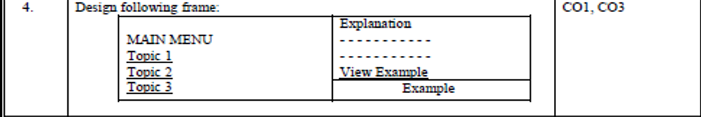  Take Topic 1: Covid-19 and its variants  Topic 2: India in Covid 19  Topic 3: Precautions to be taken in Covid 19 | CO1, CO3
5. | Make an image map showing the usage of shape, cords, href attributes in map. Link each hotspot to their respective details. All the web pages should be designed with proper background color, images, font styles and headings. | CO1, CO3
6 | Design Student Registration Form for admission in college. | CO1, CO3
7 | Create a webpage and show the usage of inline, internal and external stylesheets. | CO1, CO3
8 | Create a webpage containing a background image and apply all the background styling attributes. | CO1, CO3
9 | Create a webpage containing various Bootstrap typography classes. | CO1, CO3
10 | Create a webpage containing various different Glyphicons. | CO1, CO3
11 | Write a program to show the usage of inbuilt functions and dialogue boxes | CO2
12 | Write a program to Implement event handling using onclick, onmouseover and onmouseout events | CO2
13 | Write a Java script program to show the usage of all the date, math and string objects | CO2
14 | WAP to format the Teacher details in XML with CSS using external DTD | CO1, CO3
15 | Design a website and apply all the features of HTML, CSS, Javascript and bootstrap to make website attractive. | CO4

Assignment No 1
Copy and Paste the source code of assignment 1 from the notepad.
For formatting:
Font size - 12
Font face - Times New Roman
Paragraph spacing: 1, single

Followed by the output.

Output:
Screenshots to be attached for the output

And so on for the next assignment
New assignment will always starts with the new page

